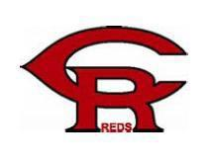
Sponsorship Form
Cedar Rapids Little Reds, Inc. 2021-2022 Baseball/Softball Season
The Cedar Rapids Little Reds Inc. (501-c3 non-profit organization) is seeking sponsors to financially support our players ages 7-14. This will be our 32nd anniversary of competitive baseball and our second year of competitive softball in Cedar Rapids. As a financial sponsor, your contributions will be used to purchase uniforms, league fees, umpires, field maintenance, tournament fees, insurance, facility rentals and many more expenses. We would not have the ability to develop fundamentally strong teams without the support and generosity of our families, fans, and sponsors
So what’s in it for you?
As a sponsor of the 2021-2022 Cedar Rapids Reds you will get the benefit of knowing that your donations are being used by a 32 year old organization known for teaching kids the fundamentals of baseball and softball, discipline, friendly competition and sportsmanship. Your company name will adorn our team dugout banner. Each of our seventeen (17) teams carries their team’s banner to every game and tournament and attaches it to their dugout during games. You will also have your company name and logo under the sponsors section of our website atwww.crreds.com .
To help us with these efforts, please complete the sponsor information below:
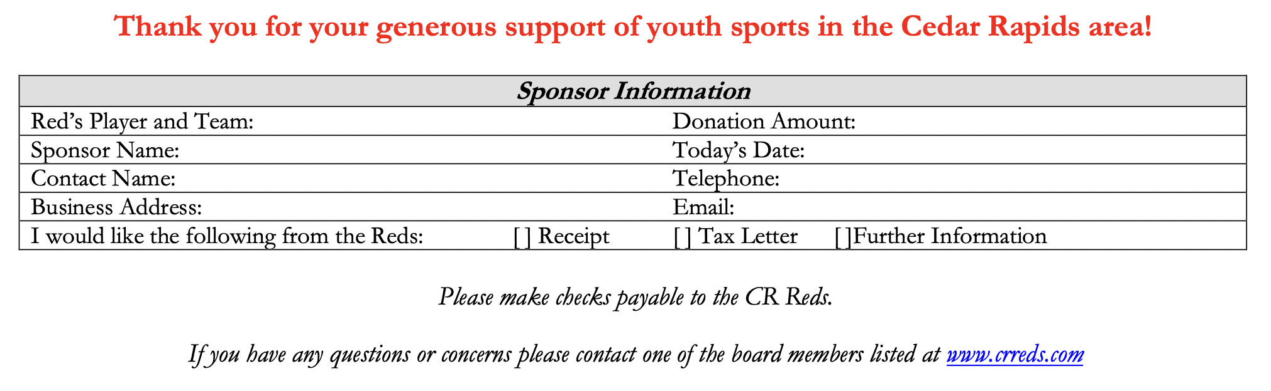
Please return this form and sponsorship no later than March 31, 2022 to your sponsored Reds player or mail to Cedar Rapids Reds, 6815 Country Ridge Dr NW, Palo, IA 52324

